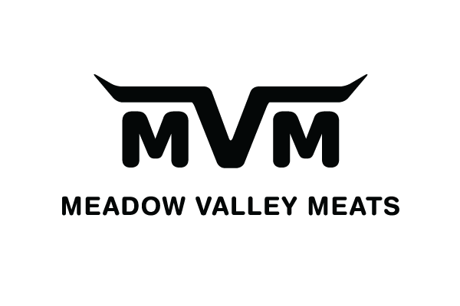

18315 Ford Road Pitt Meadows V3Y 1Z1
Phone: 604-465-4752 Fax: 604-465-4744 Email: azhar@meadowvalleymeats.com

Assalam Wa Alaikum

We enclose:

- Lamb/Sheep/Goat/Beef Pricing
- Order Form: Lamb, Goat & Sheep
- Beef Share Form

Processing Procedure and Pick-up Times

- Pitt Meadows Location will process Beef ON DAY 1
- Pitt Meadows Location will process Lamb/Goat/Sheep ON DAY 2
- Please complete order form/list with all contact info
- Whole Carcass as well as Cut-up services [8 pieces & curry cut] available at prices shown on Program
- Lamb/Goat/Sheep can be picked-up after the zabiha. There will be a wait time of 2 HOURS MINIMUM
- Beef will be cut into 8 pieces and can be picked up after the zabiha. There will be a WAIT TIME of 2 HOURS MINIMUM
- Lamb/Goat/Sheep cut into 8 pieces can be picked up the same day. There will be a WAIT TIME of 2 HOURS MINIMUM
- ALL Curry Cut orders will be ready for pick up the NEXT DAY

Other Info

- The Cut-off Date for orders is Tuesday September 6th, 2016

- Payment in full required when the order is placed. Order will not be processed until payment is received in full

